
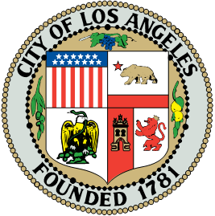
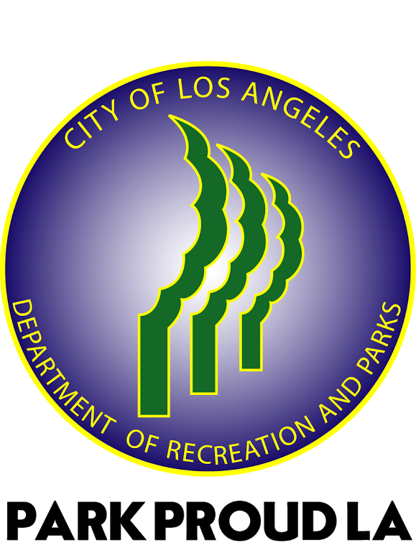

Recruitment for Park Advisory Board Members
Interest Form

The Recreation and Parks Department is accepting applications for community volunteers to serve as members of the RECREATION CENTER Park Advisory Board. The Advisory Board will be responsible for assisting and working with the Department in regards to center events, fundraising and day to day programs and activities.

The Park Advisory Board usually holds quarterly meetings. Members may also meet throughout the month on committee work and/or special projects. Members will be appointed for a 2 year term. Interviews will be scheduled and appointments will be made as soon as possible.

Applications for Park Advisory Board Membership must be returned by:
Please email applications to:
For more information contact:

Name: |  | Home Phone |  | Best contact
Address |  | Work Phone |  | Best contact
City, Zip Code |  | Cell phone |  | Best contact
Email Address:

Please answer the following:

How did you hear about the Park Advisory Board?

Why do you want to participate on the Park Advisory Board?

Do you have any background or expertise in the areas that can benefit this committee?

What current or previous committees are/have you been a part of? And in what capacity?

Each potential Park Advisory Board member MUST:
- Complete and submit a PAB interest form and attend a PAB meeting as an observer
- Interview with RAP staff and be selected to serve on the PAB by RAP staff
- Be a registered RAP volunteer, fingerprinted and cleared to volunteer
- Read and sign the Departments PAB Code of Conduct
- Be the only representative from an outside organization serving on the PAB
- Not be a member of another Department PAB; Not be a RAP employee
- Have no personal relationship* with full-time or part-time RAP staff assigned to that specific facility
- Have no personal relationship* with another PAB member serving on that specific PAB

*Personal relationship: Relatives through blood relationship or marriage; Dependents; Sharing living accommodations; or Business partners

I understand that I am a candidate and this is a preliminary step in the process of applying for a position on the Park Advisory Board. I understand there is a limited number of seats on the Board, but unlimited volunteer opportunities at the facility. I also understand that volunteering for the City of Los Angeles Department of Recreation and Parks I will abide by all Department rules and regulations relating to confidentiality.

First Name | Last Name
Signature | Date

